


Semaphore Short Friday 24 July 2026

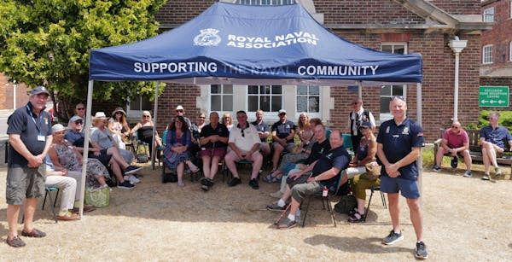

Open to suggestions

The RNA held another of our popular Open Days at Central Office last week, when we welcomed shipmates from Portland and Torfaen Branches to Lanyard House.
We are now planning next year’s programme, and you can help shape our visitors’ experience.
We get valuable feedback from those who attend Open Days, but in order to improve the offering (and we appreciate some shipmates travel long distances for the occasion) we are seeking suggestions as to what potential visitors would like to see and do when they visit us at Portsmouth Naval Base.
What would really make your day?
Any thoughts on the matter, whether you have been to a previous Open Day or not, should be directed to Jon Boreham at ams@rnassoc.org

  We want your opinion on Conference
  There is still time to let us have your views on the 2026 RNA National Conference and Annual General Meeting in Salford last month.
  We are constantly striving to improve the programme for the annual gathering, and organising Branches and Areas welcome the guidance that comes from feedback by delegates, observers and other shipmates who attend Conferences.
  Positive or negative, all comments and suggestions are valuable in giving us an insight into additions (or subtractions!) that could add to the overall experience of shipmates.
  Please fill in our feedback form – use the QR code right or click on this link to a mircrosoft form.
  

Major work ahead
Lanyard Building, the home of RNA Central Office in Portsmouth Naval Base, is undergoing something of a refit.
There is a programme of rewiring scheduled to be carried out over the coming weeks and months, and any issues that come to light as the building is surveyed will also be attended to.
Contractors are in the very early stages of surveying the site, so there are no details as yet, but there could be periods when disruption to our normal work patterns cannot be avoided.
Please keep an eye on our social media platforms and communications channels for further details as we get them.

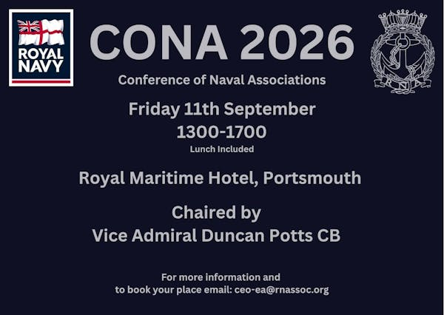

Conference call
We still have a limited number of spaces for delegates to the CONA gathering in Portsmouth in September.
CONA – the Conference of Naval Associations – is a forum for representatives of Naval associations across the UK to network, share ideas, strengthen connections and discuss issues of importance to the wider Naval community.
Whether you are involved with an association, a Branch committee, or simply interested in the organisations that support the wider Naval family, CONA offers an opportunity to meet fellow members, hear from guest speakers and contribute to important discussions.
The meeting will take place at the Royal Maritime Hotel in Queen Street, Portsmouth on Friday 11 September between 1pm and 5pm – to book your place contact Milly on ceo-ea@rnassoc.org
Please note – delegates qualify for a ten per cent discount when booking a room at the Royal Maritime Hotel if they quote CONA.

Fly the flag for the Merchant Navy

The Seafarers' Charity is calling on communities across the UK to celebrate the Merchant Navy by flying the Red Ensign on Merchant Navy Day, 3 September.
Since its inception in 2015, the campaign has grown into a significant national event.
The Red Ensign, known affectionately as the 'Red Duster,' is flown at historic properties, political establishments, civic buildings and village greens across the nation – a powerful symbol serving to highlight the indispensable role of merchant seafarers past, present, and future.
Merchant Navy seafarers’ bravery kept supply lines open during global conflicts including the world wars, as well as during crises such as the Covid-19 pandemic. Today, merchant seafarers are indispensable, handling 95 per cent of the UK’s traded goods, yet continue to face stern challenges such as the ongoing situation in the Strait of Hormuz.
For more details see https://www.theseafarerscharity.org/get-involved/merchant-navy-day



Hoofing opportunity

Royal Navy families are being offered the chance to take part in a unique five-day wellbeing programme with HorseBack UK, helping to build confidence, strengthen relationships and create lasting memories together.
Running from 3–7 August and 17–21 August in the stunning surroundings of Royal Deeside in Scotland, the Family Week combines equine-assisted learning with a range of outdoor activities designed to support wellbeing, resilience and teamwork.
Founded by former Royal Marine Jock Hutchison, HorseBack UK has supported more than 700 members of the Armed Forces community since 2009.
Through working with horses and taking part in shared challenges, participants develop confidence, communication skills and self-awareness in a relaxed, supportive environment.
The week focuses on working alongside horses from the ground, with no previous horse experience required.
Families will also enjoy activities including bushcraft, archery, nature walks, arts and crafts, treasure hunts, games and visits to local attractions, while staying together in shared accommodation.
HorseBack UK’s programmes have helped participants improve their wellbeing, relationships and confidence, with many reporting lasting positive changes long after completing the course.
This is an opportunity for Royal Navy families to step away from the pressures of everyday life, reconnect with one another and enjoy a rewarding week in the Scottish countryside.
For more details of the course, accommodation, a kit list and what you can expect, you can download full joining information using https://www.royal-naval-association.co.uk/wp-content/uploads/2026/07/HorsebackUK.pdf

Details

Thank you to the Branches who have been in touch to let us know of amendments to their entries on the RNA website.
Some may seem minor, but if it avoids confusion for someone intending to visit you on meeting night, or means a relative of a shipmate can find someone in their area to contact, it makes it worthwhile.
After all, there is no grey area – if it’s not right, it’s wrong!
Ideally, every Branch entry should have a correct time and place for their regular Branch meetings and a person to contact, which is often the Branch secretary.
Central Office does keep tabs on all RNA branches in matters such as annual returns, but we don’t usually have the latest information on meeting venues and which day of the month shipmates tend to get together.
So, we are asking each branch to check their entry under the branches directory on the website (https://www.royal-naval-association.co.uk/branches) and let us know if anything needs to be amended or updated.
Please contact Central Office via email on comms@royalnavalassoc.com, using the message line ‘Update [name] Branch’, eg Update Slough Branch.
Communication is a vital part of the RNA’s business, so it is crucial that we make sure potential members, for example, can find what they need to know about a branch straight away – in some ways, outdated information is worse than no information at all.

Pitch perfect

The SSAFA Cricket Day at Wormsley, near High Wycombe, offers the rare opportunity to play at one of the most beautiful cricket grounds in the world while supporting a leading military charity.
The big day – Friday 11 September – will feature two T20 fixtures, a barbecue lunch, hospitality, networking opportunities and an event village for company branding and engagement.
Team entries are available for £4,000 or up to 12 players, with additional spectator tickets priced at £50 per person.
Individual places are available for £350, or participants can secure a place for £50 and commit to raising a minimum of £300 for SSAFA.
Whether you are entertaining clients, rewarding colleagues or simply enjoying a day of cricket at this outstanding ground at Stokenchurch, it promises to be a unique experience in support of serving personnel, veterans and their families.
To register your interest or book your place, please contact events@ssafa.org.uk

Welsh tribute to the Soldier of the Sea

Tattoo Cymru returns this September with a new show staged in Wrexham – A Salute to the Sea Soldier.
The Royal Marines Association Concert Band will take centre stage for one night only, telling the story of Royal Marines and Seafarers whose stories are rooted in Welsh history through the ages.
Tattoo Cymru will once again bring together a unique blend of pipers, drummers, singers, dancers, drill teams and musicians for another highly anticipated display of precision, pomp and pageantry. The cast will gather together to perform a majestic finale not to be missed.
The event is at 7.30pm on Saturday 5 September at the Neuadd William Aston Hall, and tickets cost £28.50 or £41.50 for a VIP experience.
For further details see https://williamastonwrexham.com/event/tattoo-cymru?fbclid=IwY2xjawTG_KVleHRuA2FlbQIxMQBzcnRjBmFwcF9pZBAyMjIwMzkxNzg4MjAwODkyAAEekgJAnydhsf-nOTRk8FbIdaYXegvFqKFKC2obtsqAdAaipTAZ62wLxNIdmzw_aem_exAvDr3txA1bpy3qRWx6jQ

 |  |  |  |  |  |  |  |  |  |  | 

